**Developing Simple Project Management Tool for Managing Software Projects**

**System Description:**

Employees related to any software projects are the users of this system. And each user may have one on more roles in this system. Find the users and their roles as follows.

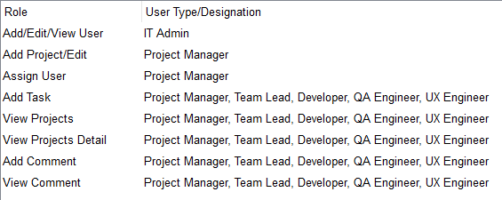

Note that any person who has been assigned to a project will be treated as **team member of that project**. So, Project Manager, Team Lead, Developer, QA Engineer, UX Engineer will be a team member when (s)he has been assigned to any projects.

**Main UI flow:**

When a user wants to enter into the system, Login UI will be appeared sign in (no need for signing up feature). When user logs into the system successfully, as his designation following home page will be appeared:

There must have at least one IT Admin into the system (as seed data). Any user with IT Admin role will get only Add/Edit/View Role and (s)he can’t be assigned to any projects as resource person.

**User Stories:**

1. **Add, Update & View Users:**

Using this Page, user information can be added and updated. Any user with IT Admin Role can Add, Edit and View User information. Note that email address will be unique and default password will be *<given email address>* + “123”. This UI will show all user information also. If you want, you can introduce separate UIs for Add, Update and View purpose.

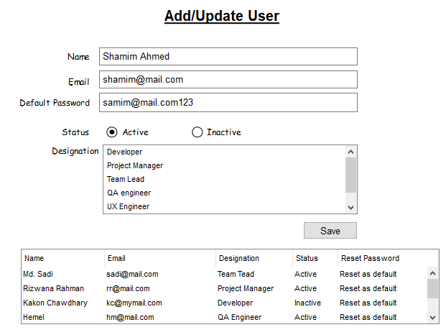

1. **Add Project:**

Any user with Project Manager Role will create project and update project information. Duration field will be a calculated figure (user will not enter it).

Note: You can keep uploaded files in database directly or you can keep these in a folder. If you want, you can introduce separate UIs for Add and Edit purpose.

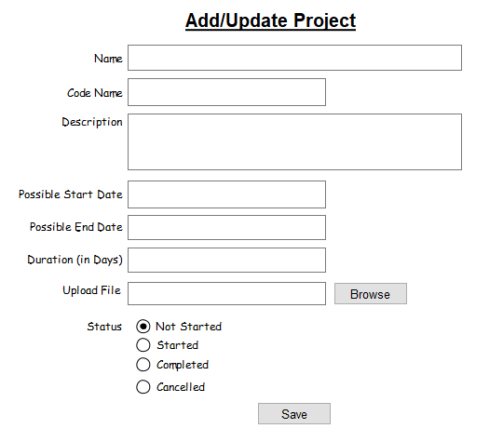

1. **Assign Resource Person:** Any user with project manager role can assign someone (except IT Admin) to any project. Even a project manager will assign himself/herself to a project. Hence, project dropdown will contain all projects and View part of this UI will display all projects and all assignee list of projects. You don’t need to keep any update feature here. Keep it simple.

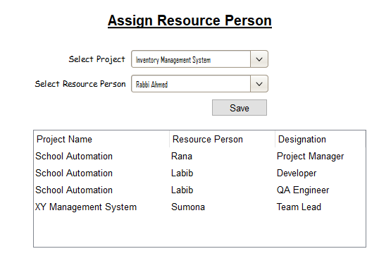

1. **View Projects:**

Any logged in user (except IT Admin) can access project information. And logged in user will see only the projects information in which (s)he has been assigned to i.e. team member will see only their project information.

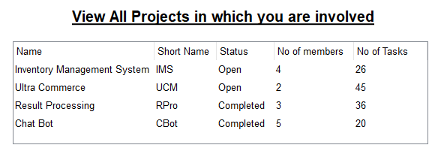

1. **Project’s Detailed View:**

By clicking on any project (of above user story), user will view project details as follows. User will create task of the selected project (See the Create Task in User Story Number: 6 )

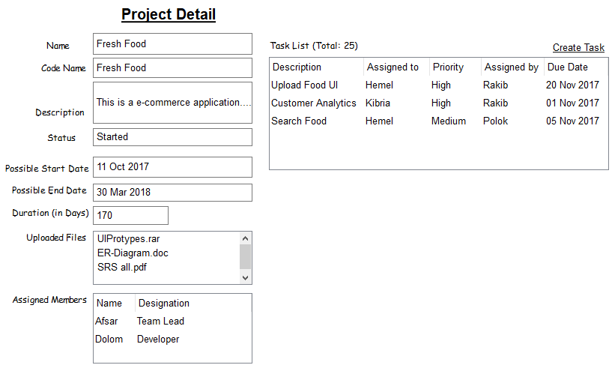

1. **Create/Add Task:**

Any logged in user can create task and assign it to someone (someone who has been assigned in this project before). For creating Task of a project, Logged in user must be an assigned resource person of that project.

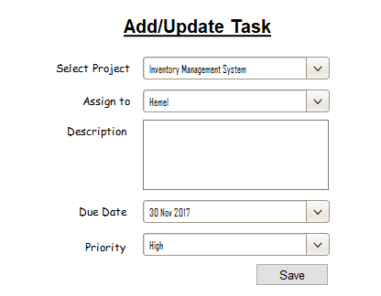

1. **Comment:**

User can put a comment against a task of a project. Anyone, assigned to the selected project can comment in any tasks, no matter (s) he has been assigned to selected task or not. i.e. any team member can comment to any tasks.

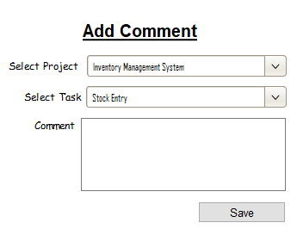

1. **View comments of a Task:**

This page will be displayed when user will click on any task of user story number: 5 (see above). Any team member of a project can view the comments.

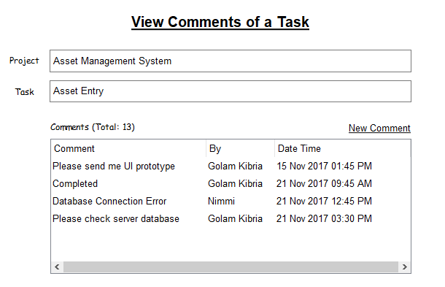

1. **And more :**

You can create a graphical (Chart, Bar diagram or whatever you want) report which you think can help management to understand something about all the projects. Note that this report will be accessible by IT Admin type users and also note that you can use any library you like, for creating this graphical report.

☺ Thank you ☺